*Student: Melis Kilic*

**Hough transform**

**HT-1. Hough transform of the set of colinear points.**

**Task 1a Hough space visualization**

%% Task 1a Hough space visualization

close all;

clearvars;

clc;

% Task 1:

A = zeros(10, 10);

A(2, 2) = 1;

A(4, 4) = 1;

A(8, 8) = 1;

% Display

figure;

imagesc(A);

title('Image A');

colormap(gray);

axis equal;

axis off;

% Task 2:

theta = -90:0.5:89.5;

[H, theta, rho] = hough(A, 'Theta', theta, 'RhoResolution', 0.1);

% Display

figure;

imshow(imadjust(mat2gray(H)), 'XData', theta, 'YData', rho, 'InitialMagnification', 'fit', 'Colormap', parula);

title('Task 2 Hough Space');

xlabel('Theta (degrees)');

ylabel('Rho');

axis on;

axis normal;

% Task 3:

A(9, 9) = 1;

A(10, 10) = 1;

[H, theta, rho] = hough(A, 'Theta', theta, 'RhoResolution', 0.1);

% Display

figure;

imshow(imadjust(mat2gray(H)), 'XData', theta, 'YData', rho, 'InitialMagnification', 'fit', 'Colormap', parula);

title('Final Hough Space (5 sinusoids)');

xlabel('Theta (degrees)');

ylabel('Rho');

axis on;

axis normal;

**Result of the code:**

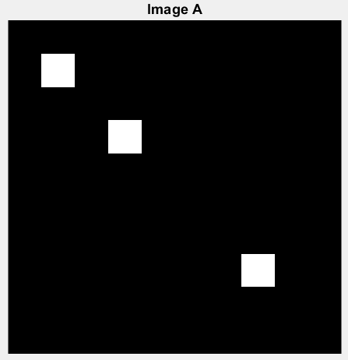

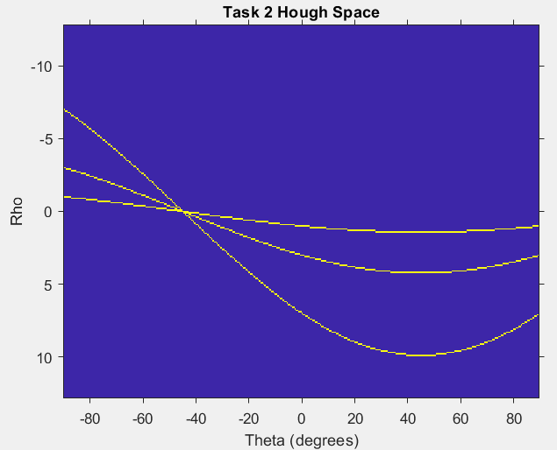

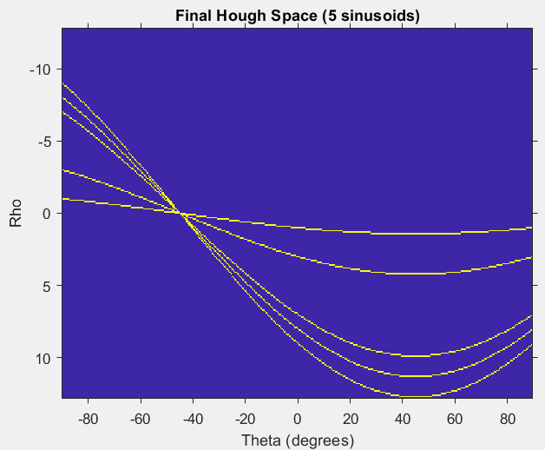

***Based on theory from the lecture answer the questions:***

* ***What is represented by the axes of the Hough space image?***

Axes of the Hough space image represent the parameters of the Hough transform: theta (angle) and rho (distance from the origin).

* ***Which sinusoid corresponds to which pixel of the image and why?***

Each sinusoid corresponds to a line in the image space passing through a point. The intersection point in the Hough space represents the parameters (theta, rho) of that line.

* ***Why do all three sinusoids intersect at one point?***

Three colinear pixels in the image result in three sinusoids intersecting at one point because they lie on the same line in the image space.

**Task 1b Parameters of the straight line**

%% Task 1b Parameters of the straight line

% Task 4:

[maxValue, maxIndex] = max(H(:));

[row, col] = ind2sub(size(H), maxIndex);

% Display

figure;

imshow(imadjust(mat2gray(H)), 'XData', theta, 'YData', rho, 'InitialMagnification', 'fit', 'Colormap', parula);

title('Intersection Point in Hough Space');

xlabel('Theta (degrees)');

ylabel('Rho');

axis on;

axis normal;

hold on;

plot(theta(col), rho(row), 'rx', 'MarkerSize', 10, 'LineWidth', 2);

% Task 5:

x = 0:0.1:10;

thetaRadians = deg2rad(theta(col));

y = (rho(row) - x .* cos(thetaRadians)) / sin(thetaRadians);

% Task 6:

% Display

Figure;

imagesc(A);

title('Image A with Detected Line');

colormap(gray);

axis equal;

axis off;

hold on;

plot(x + 1, y + 1, 'r', 'LineWidth', 2);

hold off;

**Result of the code:**

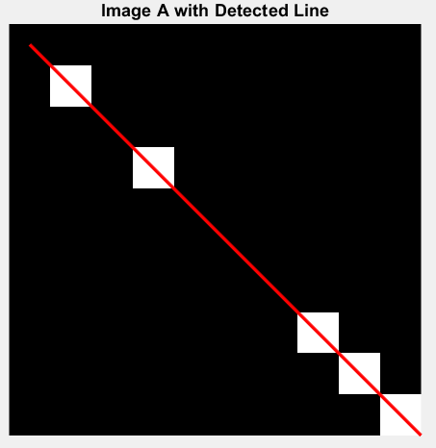

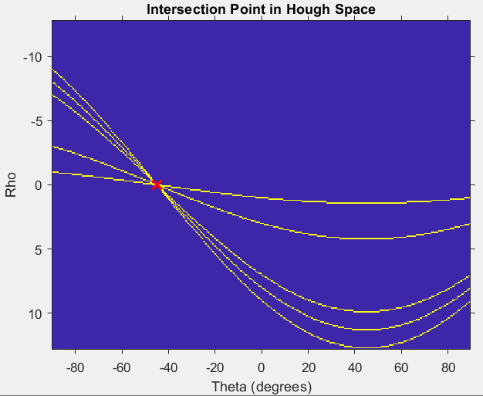

**HT-2. Hough transform of the set of non-colinear points.**

**HT-3. Hough transform of an artificial image “squares”**

close all;

clearvars;

clc;

originalImage = imread('squares.png');

edgesImage = edge(originalImage, 'Canny');

[H, theta, rho] = hough(edgesImage);

% Display results in subplots

figure('Name', 'Hough Transform Results');

colormap(gray);

subplot(2, 2, 1);

imshow(originalImage);

title('Original Image');

axis on;

subplot(2, 2, 2);

imshow(imadjust(mat2gray(H)), 'XData', theta, 'YData', rho, 'InitialMagnification', 'fit');

title('Hough Space');

xlabel('Theta (degrees)');

ylabel('Rho');

axis on;

axis normal;

hold on;

subplot(2, 2, 3);

imshow(edgesImage);

title('Edges');

axis on;

subplot(2, 2, 4);

imshow(imadjust(mat2gray(H)), 'XData', theta, 'YData', rho, 'InitialMagnification', 'fit');

title('Hough Space with Expected Maxima');

xlabel('Theta (degrees)');

ylabel('Rho');

axis on;

axis normal;

hold on;

% Use houghpeaks to look for 8 maxima

peaks = houghpeaks(H, 8, 'NHoodSize', [19, 19]);

% Plot maxima in Hough space

plot(theta(peaks(:, 2)), rho(peaks(:, 1)), 'o', 'MarkerSize', 10, 'MarkerEdgeColor', 'r', 'LineWidth', 2);

% Find and display lines in the image using houghlines

lines = houghlines(edgesImage, theta, rho, peaks);

% Display the lines on the original image

subplot(2, 2, 1);

hold on;

for k = 1:length(lines)

xy = [lines(k).point1; lines(k).point2];

plot(xy(:, 1), xy(:, 2), 'LineWidth', 2, 'Color', 'g');

end

hold off;

% Display the lines in the Hough space with maxima marked

subplot(2, 2, 2);

for k = 1:length(lines)

plot(lines(k).theta, lines(k).rho, 'g', 'LineWidth', 2);

end

hold off;

**Result of the code:**

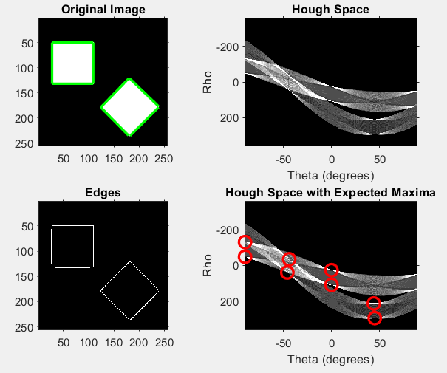

**HT-4. Hough transform of a real-life image “house”**

close all;

clearvars;

clc;

originalImage = imread('house.png');

% Convert to grayscale if the image is in RGB format

if size(originalImage, 3) == 3

grayImage = rgb2gray(originalImage);

else

grayImage = originalImage;

end

edgesImage = edge(grayImage, 'Canny', [], 1.5);

[H, theta, rho] = hough(edgesImage);

% Display

figure('Name', 'Hough Transform Results for house.png');

colormap(gray);

% Original image

subplot(1, 3, 1);

imshow(originalImage);

title('Original Image');

axis on;

% Edges with houghlines superimposed

subplot(1, 3, 2);

imshow(originalImage);

title('Edges with Houghlines');

axis on;

hold on;

% Find and display lines in the image using houghlines

peaks = houghpeaks(H, 8, 'NHoodSize', [19, 19]);

lines = houghlines(edgesImage, theta, rho, peaks);

for k = 1:length(lines)

xy = [lines(k).point1; lines(k).point2];

plot(xy(:, 1), xy(:, 2), 'LineWidth', 2, 'Color', 'g');

end

hold off;

% Edges

subplot(1, 3, 3);

imshow(edgesImage);

title('Edges');

axis on;

% Hough space with maxima marked

figure('Name', 'Hough Space with Maxima');

imshow(imadjust(mat2gray(H)), 'XData', theta, 'YData', rho, 'InitialMagnification', 'fit');

title('Hough Space with Maxima');

xlabel('Theta (degrees)');

ylabel('Rho');

axis on;

axis normal;

hold on;

plot(theta(peaks(:, 2)), rho(peaks(:, 1)), 'o', 'MarkerSize', 10, 'MarkerEdgeColor', 'r', 'LineWidth', 2);

hold off;

**Result of the code:**

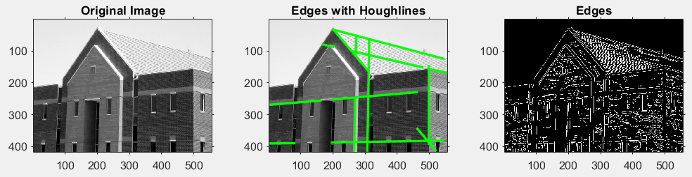

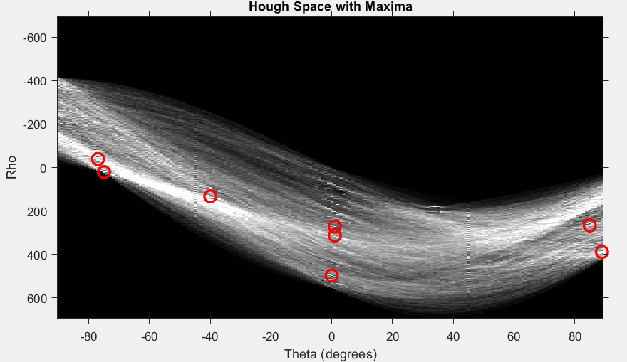

**HT-5. Hough transform of real-life image with morphological operations**

close all;

clearvars;

clc;

realImage = imread('real_squares.png');

% Convert to grayscale if the image is in RGB format

if size(realImage, 3) == 3

grayImage = rgb2gray(realImage);

else

grayImage = realImage;

end

% Apply filtering, morphological processing, binarization, and edge detection

threshold = 0.5;

binaryImage = imbinarize(grayImage, threshold);

se = strel('square', 5);

closedImage = imclose(binaryImage, se);

edgesImage = edge(closedImage, 'Canny');

[H, theta, rho] = hough(edgesImage);

peaks = houghpeaks(H, 8, 'NHoodSize', [19, 19]);

% Display

figure('Name', 'Hough Transform Results for real_squares.png', 'Position', [100, 100, 1200, 400]);

% Original image

subplot(1, 3, 1);

imshow(realImage);

title('Original Image');

axis on;

% Processed image

subplot(1, 3, 2);

imshow(closedImage);

title('Processed Image');

axis on;

% Edges with houghlines superimposed

subplot(1, 3, 3);

imshow(realImage);

title('Edges with Houghlines');

axis on;

hold on;

% Find and display lines in the image using houghlines

lines = houghlines(edgesImage, theta, rho, peaks);

for k = 1:length(lines)

xy = [lines(k).point1; lines(k).point2];

plot(xy(:, 1), xy(:, 2), 'LineWidth', 2, 'Color', 'g');

end

hold off;

% Hough space with maxima marked (in a separate figure)

figure('Name', 'Hough Space with Maxima', 'Position', [300, 100, 600, 400]);

imshow(imadjust(mat2gray(H)), 'XData', theta, 'YData', rho, 'InitialMagnification', 'fit');

title('Hough Space with Maxima');

xlabel('Theta (degrees)');

ylabel('Rho');

axis on;

axis normal;

hold on;

plot(theta(peaks(:, 2)), rho(peaks(:, 1)), 'o', 'MarkerSize', 10, 'MarkerEdgeColor', 'r', 'LineWidth', 2);

hold off;

**Result of the code:**

